School Council

Financial Information Quick Guide

May 24, 2019

Table of Contents

Overview
Composition of School Council
Elections & Term of Office
Incorporation & Charitable Registration Status
Remuneration and School Council Expenses

Roles and Responsibilities
School Councils
Principal
Chair/Co-Chair(s)
Parent Representatives

Financial Policies and Procedures
Fundraising - Guiding Principles
Eligible and Ineligible Uses of School Generated Funds
Cash Handling and Disbursements
Bank Activities and Signatories
Tracking Funds
Bank Reconciliation and Reporting
Investments
Records Retention
Use of e-Commerce Platforms and Applications

KEV School Cash Online
Online Collections - Monetary Donations and Items for Sale
Accounting Options Using School Cash Online
School Cash Online Reports
Benefits of using School Cash Online
HST Rebates and Merchant Fee Charges

Financial Reporting
Semi-Annual and Year End PSAB Reports
School Council Financial Plan and School Needs Assessment

Other Topics
Gifts in Kind Donations
Tax Receipts and Split Tax Receipt Rules
Lotteries and Games of Chance
Entering into Contracts and Engaging Vendors
School Council Insurance

Appendix A: TDSB School Cash Online Donation Module Quick Guide and FAQs

Overview

Ontario Regulation 612/00 addresses three key areas: Purpose of School Councils, operational matters and obligation of Boards and Principals to consult with School Councils.
The purpose of School Councils is to improve pupil achievement and enhance the accountability of the education system through active parent participation. Their primary means of achieving its purpose is by making recommendations in accordance to Ontario Regulation 612/00 to the Principal of the school and the Board that established the council. (O. Reg 612/00 s.2)
Composition of School Council
The Regulation establishes that a School Council consists of the following members:
Voting members:
- Parent members, including the chair and co-chair who must be parent members.
- One teacher employed in the school, other than the Principal or Vice Principal.
- One non-teaching employee of the school.
- One student for secondary schools (optional for elementary schools)
- One or more community representatives appointed by the elected council
- One member of the Ontario Federation of Home and Schools if the association is represented at the school.
Non-Voting members:
- School Principal or designated Vice Principal

The School Council shall have a chair, or if the by-laws of the council provide, two co-chairs, who are parent members of the council. The chair or co-chair cannot be a TDSB employee. A School Council may have other officers, such as treasurer or secretary, as outlined in their council by-laws.
A Board employee who works at the school his/her child attends is not eligible to serve as a parent member of the council, nor as chair, co-chair, treasurer or secretary. However this employee can serve as a teaching or non-teaching representative. The Board employee can serve as a School Council member of their child’s school as long as they declare their status as a Board employee and are not employed at the school.
Elections and Term of office:
School Council elections are held annually within the first thirty calendar days of the school year for the one-year term. The regulation does not restrict the number of times that a member can be re-elected or reappointed to School Council. The first meeting of the new School Council must occur within 35 days of the election and parents must be given 14 days’ notice of the election date.
Incorporation and Charitable Registration Status:
Ontario Regulation 612/00 prohibits School Councils from being incorporated, as they belong to the corporate entity of the Toronto District School Board. The mandate of the School Council does not require any separate legal or charitable registration status.
Toronto District School Board is a registered charity in Ontario - Charity Registration number: 89578 8222 RR0001. When schools and School Councils are soliciting donations or applying for grants, the grant application may require the school or School Council’s charitable registration number. Schools must obtain pre-approval from the Board and the Principal, before using TDSB’s charitable registration number for any purpose.
Please contact businessdevelopment@tdsb.on.ca to obtain pre-approval.
Remuneration and School Council Expenses:
In accordance to Ontario Regulation 612/00, School Council members cannot be remunerated for their work on School Councils. No honorarium shall be paid to any person serving as a member of School Council.
Each TDSB school has budget allocated to support expenses incurred as part of School Council business. This is comprised of a calculated per pupil allocation ($1.25 per pupil, minimum $300 up to $1,000 maximum) and parent engagement funds of $500 per school. School budget allocations are posted annually on the TDSB website. Link: https://www.tdsb.on.ca/About-Us/Business-Services/Budgets-and-Financial-Statements/School-Budgets.

Roles and Responsibilities

School Councils
School Councils are advisory bodies of the Board. They may make recommendations to the Principals or to the Toronto District School Board on any matter.
They are to consult with parents of students enrolled in the school. The Board shall consider each recommendation made by the School Council to the Board. The Board shall also advise the School Council of any actions taken in response to the recommendation.
Principal
The school Principal will provide guidance and support to help their School Council achieve the goals of the school.
The Principal is required to attend and participate in every School Council meeting. Alternatively, the Principal may designate the Vice-Principal to attend in his/her place. Principals and/or Vice-Principals are not eligible to vote on any matters. Principals are also responsible for oversight of School Council activities to ensure they align with the Board’s mandate and comply with Board policies and procedures, and Ontario Regulation 612/00.
Chair/Co-Chair(s)
The chair/co-chair(s) must be a parent who is not employed by the school board. They are voting members of the council who also perform the same duties as other School Council members. Some of the Chair/Co-Chair(s)’s duties include:
- School Council Meetings: Arrange meetings, prepare meeting agendas, chair meetings and work with the secretary or other School Council members to ensure they maintain records of minutes at each meeting.

- Communication and Conflict Resolution: Facilitate resolution of conflict, participate as ex-officio members of all committees established by the School Council, communicate with the school Principal on behalf of the council, be aware of and disclose any conflicts of interest within the School Council.

- Financial Responsibilities: Work with the School Council Treasurer to ensure accurate and timely recording and reporting of School Council funds. The Chair/co-chair may also approve disbursement requests as a bank signatory. They should also ensure all funds collected are counted, verified by another individual. School Council funds must be kept in the school’s locked safe until they are ready for deposit.
Parent Representatives
Parent representatives are voting members who participate on any committees established by the School Council, contribute to the discussions of School Council, and solicit the views of other parents and members of the community.

Financial Policies and Procedures

Fundraising – Guiding Principles
School Councils may conduct fundraising as long as the fundraising activities are conducted in accordance with Board policies and guidelines.
- Funds must be raised for specific purpose(s) and spent according to the purpose(s) communicated.
- Intended use of funds must be clearly defined prior to the start of the fundraising and/or documented in the School Council financial plan approved on or before October 31 of each school year.
- It is recommended that funds raised be spent within 2 years to benefit current students, unless designated for future needs or other long-term fundraising projects or initiatives.
- Unspent School Council funds will be carried forward to the following year for future use.
- Fundraising proceeds raised by School Councils, as well as corresponding spending, must be reported as part of the Board’s year-end financial reporting process.

Below are TDSB policies and procedures applicable to School Councils:
- Fundraising Policy P021 and Operational Procedure PR508
- Advertising Policy P006 and Operational Procedure PR507
- Distribution and Display of Materials for Students and Parents from External Groups Policy P041 and Operating Procedure PR565
Eligible and Ineligible Uses of School Generated Funds
Examples of eligible uses of school generated funds:
Complement budget | Funds can be used to complement but not replace public funding for education. Funds can be used for items that are not funded through the school’s budget.
Student subsidies | Funds can be used to offset costs for students who cannot afford to fully participate in school activities.
External charities | Activities to raise funds for support of external charities can be organized if the charity is registered on the CRA website. These funds must be recorded in a separate sub-ledger and included in the PSAB report.
Co-Curricular activities | Examples: Art, music, drama, sports activities or other activities organized outside of instructional hours. These should be incorporated into the School Council budgeting process.
Student nutrition programs | Parental contributions can subsidize nutrition programs. If the nutrition program is funded via TFSS (Toronto Foundation for Student Success) then the funds are reported through the TFSS nutrition bank account.
School yard, playground and outdoor facility improvements | Funds can be used for these purposes within the limits outlined in the Board Procedures.

Examples of ineligible uses:
Core curriculum materials | These items are to be covered by the school budget (textbooks, workbooks, classroom learning materials, etc.)
Facility renewal funded through renewal grants | Funds cannot be used for capital infrastructure improvements, facility renewal, maintenance or upgrades if they are fully funded through the school’s renewal grants from the Ministry of Education.
Goods or services from Board employees that give rise to potential conflict of interest | Funds cannot be used to pay for goods or services from Board employees, or School Council members, or other purchases that would contravene with Section 217 of The Education Act or P057 Conflict of Interest Policy.
Monetary gifts to staff and School Council members for appreciation | Purchases of gifts, gift cards, or monetary payments to staff and school council members are prohibited.*
Professional development, travel, meals & hospitality for staff | Funds used towards these expenses are prohibited.*
Investments other than those permitted by the Board and Regulation 41/10 of The Education Act | All investments made using school generated funds must be reported and approved by the Board and must meet the eligibility requirements under the Ministry Regulation 41/10.
Political activities or administrative expense | Funds may not be used for political activities, groups, candidates, such as political donations. They also cannot be used for administrative expenses.
*Light refreshments, at a reasonable cost, are permitted when served at school council events, holiday school events or year-end celebrations that are attended by the school community.

Cash Handling and Disbursements:
Deposits and Cash Handling:
- All funds must be kept securely at the school until the funds are deposited into the bank. It is recommended that each school have a secure safe. The Board’s insurance will not reimburse schools for missing or stolen funds if they are not locked inside the school safe.
- Cash and cheques collected should not be kept unsecured in desk drawers, shelves or open areas. Funds should not be brought home or kept in vehicles.
- Funds collected are independently counted by at least 2 people. They must be recorded on the Deposit Voucher and deposited to the bank account promptly.
- For School Councils that have a separate bank account, two School Council members can be assigned to count and verify the funds.
- For School Councils using the non-board bank account for deposit, one of the two individuals counting and verifying the funds should be a Board staff.
- Any supporting documents for the collection of funds (such as order forms) are kept with the Deposit Voucher.
- All funds collected and prepared for deposit must be recorded on the Deposit Log.
- Funds are to be placed in an envelope and sealed, with the Deposit Voucher attached.
- Funds should be deposited on a weekly basis, or on the scheduled PACE Credit Union pick up date. Funds should not be kept in the school safe for a prolonged period of time such as over summer months or holiday breaks.
Purchases and Disbursements:
- Expenditures cannot be paid from cash collected. All funds collected must be deposited into the bank account in full. Payments must be paid out from the bank account as per the amounts approved by the two bank signatories.
- All payments must be pre-approved by the School Council.
- All disbursements must comply with the Board’s procurement policy and procedures.
- Board approved vendors should be used for the purchase of goods and services, including fee-for-service contractors such as guest speakers. These vendors should be paid through the Board’s SAP system.
- All disbursements must be recorded on a timely basis.
- Cheques made payable to “Cash” is not acceptable.
- Payments or reimbursements should only be made upon the presentation of original invoices or itemized receipts.
- Prepayments are generally not acceptable, except for deposits for booking an event or venue.
- Cheques must be pre-numbered. All cheques must be signed by two signatories.
- Pre-signing of cheques, uses of signature stamps or electronic signatures are not acceptable.
- Unused cheques should be stored in a designated, secure location in order to prevent fraud or theft.
- Cheques not cashed within six months are stale-dated and should be noted in the accounting records after issuing a stop payment to the bank.
Bank Activities and Signatories
Bank Account Authority
If the School Council has a separate bank account, the chair/co-chair(s), treasurer and/or other School Council executive shall act as approved signing officers of the School Council bank account.
It is strongly recommended that the Principal be added as a signatory to the School Council bank account. This ensures there is a Board representative with account access. It also minimizes any potential risks and disruptions associated with unplanned or sudden departures of School Council members who are signatories to the bank account. Under PACE Credit Union’s Signing Authority Resolution, Principals are appointed to act on behalf of the Board to operate all bank accounts under the TDSB schools’ name, including School Council accounts. Therefore, the Principal is required by PACE Credit Union to be a signatory to the bank accounts.
The Board is accountable for TDSB School Councils’ financial activities. Although it is not required for the Principal to approve every disbursement request, the Principal must have access to view School Council account bank statements and financial reports. The School Council is required to follow the Board’s recommended protocols around funds handling, record keeping and reporting. Copies of the School Council bank reconciliation reports, transaction ledgers and bank statements must be retained at the school office.
If the School Council does not have a separate bank account and uses the school’s school generated funds (non-board) bank account for their collections and disbursements, then the Principal must ensure that the School Council members are provided with all of the necessary financial reports prior to each School Council meeting. This ensures that the School Council members are kept apprised of their financial activities.
Please note that:
- PACE Credit Union is the recommended financial institution for schools and School Councils, as they provide complimentary funds pick-up service. They also provide monthly reports of all TDSB school account signatory changes and cash count discrepancy notifications to the Board’s Finance Department.
- The School Council bank account must be in the name of the school.
- There is a maximum of one School Council bank account per school.
- Personal accounts cannot be used for School Council collections and disbursement activities.
- Where schools participate in Lotteries and Games of Chance, a separate bank account must be maintained for the collections and disbursements, as required by the Alcohol and Gaming Commission of Ontario. (https://www.agco.ca/lottery-and-gaming/charitable-lottery-licensing-overview)

Adding the Board as a Delegate to your PACE Credit Union School Council Account

School Councils now have the option to authorize TDSB as a “delegate” to their PACE Credit Union bank accounts. This provides the Board with “view-only” access to the account activities and balances. This will help facilitate support around bookkeeping, bank reconciliations and year-end reporting.

To add TDSB as a delegate to the School Council bank account, please contact us at BusinessHelpDesk@tdsb.on.ca to kick start the process. (Note this is optional for School Councils)

Tracking Funds
- All School Council funds activities are to be tracked in a register.
- Electronic record keeping (e.g. Quicken or Excel) is preferred over a manual handwritten register.
- The School Council register should account for all deposits and disbursements, including cheques cashed or voided.
- Voided cheques must be marked “VOID”. The void cheques should be retained.
- The register is continuous from year to year. The opening balance of the current year should match the closing balance of the prior fiscal year.
- The Treasurer is required to pass the accounting records to the next incoming Treasurer.
Bank Reconciliation and Reporting
- Bank reconciliations are to be prepared on a monthly basis.
- If there are any suspicious or fraudulent transactions found on the bank statements, you must notify the bank within 90 days of the transaction date, in order to recover the funds from the financial institution.
- School Council bank reconciliations, bank statements and registers should be shared with the Principal and Office Administrator.
- A financial summary of inflows, outflows and account balances should be shared at each monthly School Council meeting.
Investments
Although this practice is not recommended, where a School Council has excess funds, they may be invested in the name of the school as permitted by Reg. 471/97 of the Education Act and Board policy and practices.
School Councils must notify the Board and receive the Board’s approval before investing any of the funds. These funds should not be invested for a period exceeding one year.
School Councils are required to provide a consolidated investment report, outlining the balances and interests earned to the Board at year-end, as part of the year-end reporting process.

Records Retention
All original documents, including paid invoices, cancelled cheques, bank statements, support for deposits and bank reconciliations shall be retained in the school for seven years for audit purposes. The records of each year should be boxed, labeled with a description of contents and the record destruction date, and securely stored in the school. School Councils’ electronic files should also be saved in a shared folder, to ensure the incoming School Council and the school administrators have access to the current and prior years’ records.
Use of e-Commerce Platforms and Applications
There may be e-Commerce applications in the market that can better meet the needs of the School Council. Below are some guidelines around the use of these applications:
Application | Recommended Guidelines
Square Reader  (Used for credit card payment processing during fun fairs, silent auctions, etc.) | The Principal must have oversight of the Square Reader account set up, usage, funds tracking and financial reports. Account must be linked to the school’s non-board or school council account, not external or personal bank accounts. The Square Reader should only allow deposits to the designated account, not refunds or payments from the account. Users should be notified about the transaction charges in advance. The Square Reader can be purchased through TDSB vendors through SAP. The account must be terminated as soon as the event is over, and the Square Reader should be stored in a secure place in the school.
Paypal or other online payment / money transfer portal | Use of Paypal for School Council collections is not recommended as the Board has no control over the account set up and routing of funds. KEV School Cash Online can be used for online collection activities. There are costs to School Councils for the use of School Cash Online.
Other e-Commerce Applications or Platforms | e-Commerce applications or platforms can be used by School Councils, as long as they do not pose any financial, control, privacy or fraud risks to the Board and to users. They also must not conflict with existing Board contracts. Please consult with your Principal and your school’s Financial Support Officer before using these applications.

KEV School Cash Online

KEV School Cash Online is an online platform that allows parents or guardians to purchase items. It also allows donors to donate to schools and fundraising initiatives through the online portal.
To create an account or log in to the system, please visit: https://tdsb.schoolcashonline.com/
Online Collections – Monetary Donations and Items for Sale
Can School Councils use the School Cash Online system?
Yes! The School Cash Online system can be used by School Councils for their fundraising initiatives and collection activities.
There are two ways School Councils can use the system:
- For Collection of Monetary Donations

When a school or School Council is directly soliciting monetary donations from donors, the Online Donation Module can be used to collect and track donations, as well as issue tax receipts automatically for donations of any amount.

School Councils can use the TDSB online donation page, or create a separate customized webpage for their School Council or school fundraising initiative.

Please refer to Appendix A: Quick Guide to the Online Donation Module and Frequently Asked Questions.

For Collection of Items for Sale

School Councils can post items for sale through the School Cash Catalogue module. Examples of items they can sell through this module include pizza lunches, merchandise for fundraising, movie night and concert tickets, etc. The purchaser cannot receive any tax receipts for these purchases as they are receiving goods or services in return.
Accounting Options Using School Cash Online
There are three options for School Councils.
Note that only the school’s Office Administrator, Finance Support Officer or Business Help Desk have access to posting items for sale on behalf of School Councils through School Cash Online. At this time, School Councils do not have direct access to post items for sale or generate reports from School Cash Online.

Option A

School Councils can use the school’s existing school generated funds (non-board) account to post items, collect fees and issue payments.

The school can create a “School Council” category, a profit & loss account, in their School Cash Online ledger to track all School Council revenues through the School cash catalogue module.

Collections will be directly deposited into their school generated funds (non-board) account.

Vendors are to be paid directly from the same category, through the non-board account. This way, School Councils can take advantage of the Board’s HST rebates.

Under this arrangement, the School Council would not need to maintain a separate bank account, as all transactions would flow through the school’s non-board bank account. School Council transactions will be reconciled by the school Office Administrator. The School Council would not need to prepare or submit any year-end PSAB reports as all revenues and expenses would be consolidated with the school’s non-board account.

School Cash Online reports outlining amounts collected, refunded, waived or owing, items and quantities ordered by student, cheques issued, and revenue and expense balances can be provided to the School Council for reporting purposes.

Option B

School Councils can use the school’s existing school generated funds (non-board) account to post items and collect funds. All funds collected can be redirected to the School Council bank account.

Under this option, the school can create a “Due to School Council” category, under the liability account, in their school generated funds ledger. School Councils can post items through that account. All funds received will be transferred to the School Council bank account periodically or at the end of the fundraising event. The Office Administrator would issue a cheque to the School Council bank account for total amounts collected.

The School Council is responsible for recording all deposits and disbursements through their bank, and to prepare bank reconciliations. Payments made to vendors will not be eligible for the school board HST rebates. They are required to prepare and submit year-end PSAB reports to the Board, outlining their revenues and expenditures.

Item Attachment Reports and Item Order Reports can be provided to the School Council. Please refer to the School Cash Online Reports section of this guide for the reports available.

Option C

Link the School Council bank account to School Cash Online

The School Council can link their bank account to the School Cash Online system. Under this option, collections will be directly deposited into the School Council bank account.

To set up this arrangement, the School Council must provide a VOID cheque to the Board for the account set up and transaction testing. A set-up fee will be charged for this service if requested after June 1, 2019.

School Councils will be responsible for compiling their bank reconciliations and year-end PSAB report submissions.

COMPARISON OF ACCOUNTING OPTIONS USING SCHOOL CASH ONLINE

 | Option A  Use the Non-Board funds account for School Council activities | Option B  Transfer Collections to School Council Bank Account | Option C  Deposit Collections directly to School Council Bank Account
Items for Sale are to be posted by: | School Administrator, Finance Support Officer or Business Help Desk
Funds collected are deposited to: | School’s Non -Board Account | School’s Non-Board account, and then transferred manually to School Council account | School Council account
Payments to vendors and reimbursements are paid through: | School’s Non -Board Account | School Council account | School Council account
Are School Councils required to prepare semi-annual and year-end PSAB reports? | No | Yes | Yes
Where are transactions tracked? | Automatically through the School Council Ledger in School Cash Online | Manually recorded by the treasurer in the School Council records | Manually recorded by the treasurer in the School Council records
What reports should be provided to the School Council? | Item Attachment/ Option/ Order Reports  Customized Transaction Report of the School Council Category | Item Attachment/ Option/ Order Reports  Customized Transaction Report of the Due to School Council Category | Item Attachment/ Option/ Order Reports  Batch Report outlining bank transaction details
Can HST Rebates be claimed on purchase transactions? | Yes | No, unless purchases are made through SAP or School Cash Online | No, unless purchases are made through SAP or School Cash Online
School Cash Online Reports
There are different types of School Cash Online reports that can facilitate reconciliation and reporting of School Council transactions. You may request these reports from your school’s Office Administrator, Finance Support Officer or Business Help Desk at businesshelpdesk@tdsb.on.ca or 416-395-8080.
Item Attachment, Item Order, Item Option, Customized Transaction and Batch reports – These five reports provide detailed information around purchase information, bank deposit dates and batch numbers that appear in bank statements.
Donation Report – This report outlines the monetary donations received through the online donation module. See Appendix A of this guide for details.

[Sample] Item Attachment Report
- Provides total paid, waived, refunded, owing by student. Outlines purchase date, item name and payment method.

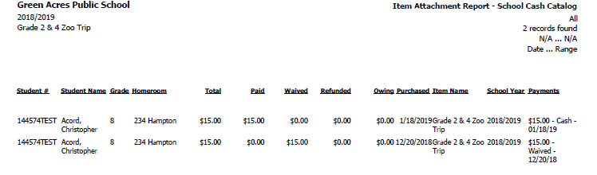

[Sample] Item Order Report
- Provides total paid, waived, refunded, owing by student. Outlines purchase date, item name and payment method. Provides list of options selected for the item purchased.
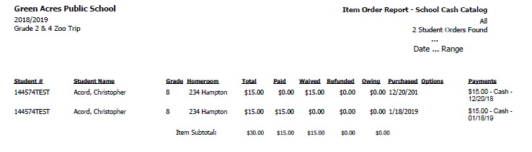
[Sample] Item Option Report
- Provides the number of different options and quantities purchased by the students in the class. This will assist with the ordering process to determine number of orders required for each item.

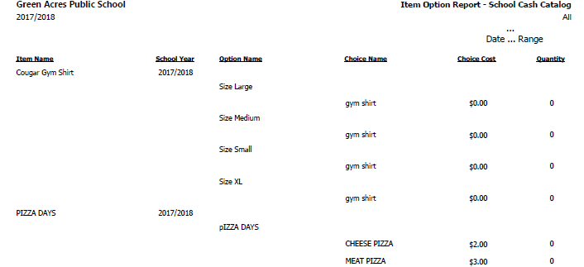

[Sample] Batch Reports - Summary
- Provides total deposits by date as amounts appear in bank statements, by batch number.
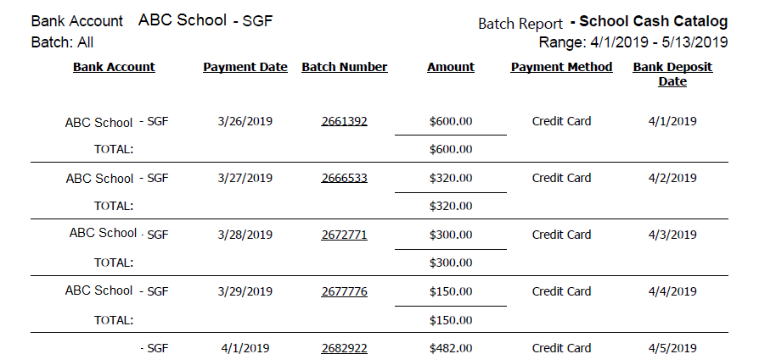
[Sample] Batch Reports - Detailed
- Provides bank deposits by date, by purchaser, by payment method, as amounts appear in bank statements, by batch number.
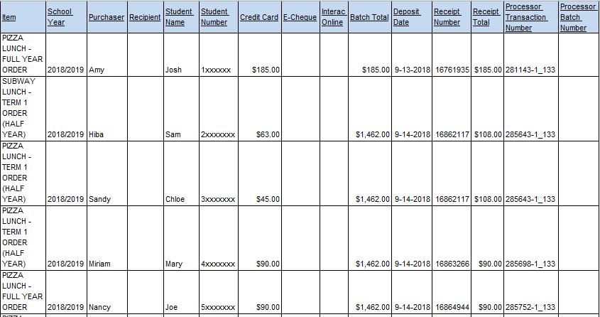

[Sample] Customized Transaction Report – Report #11
- Provides transactions by date, School Council or Due to School Council category, amounts and date cleared from the bank.
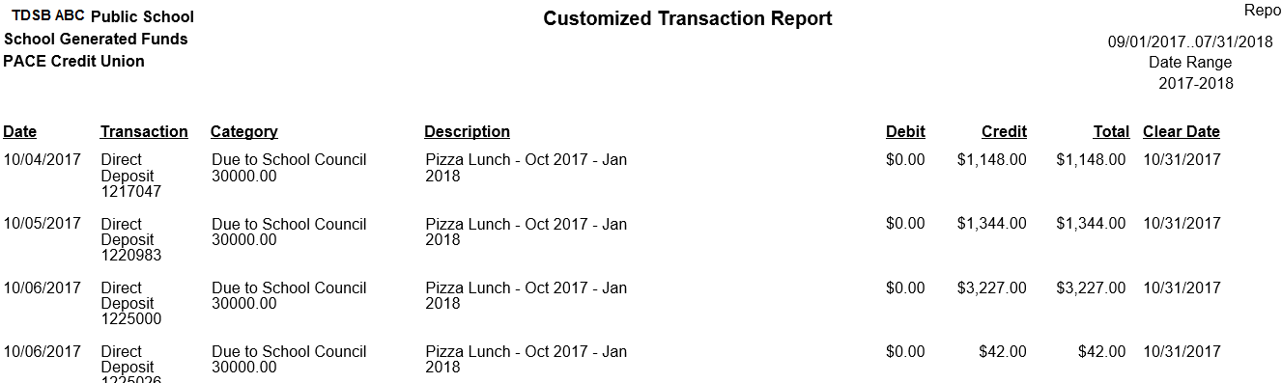

Benefits of using School Cash Online
- Minimize cash handling and cash counting, which helps reduce the risk of fraud, theft and missing funds.
- Convenient for parents or students to pay for items remotely, through their computers or mobile devices.
- Can eliminate the preparation of year-end or semi-annual PSAB year-end reports (This only applies to School Councils who use the school’s school generated funds or non-board account for transaction activities).
- Automatic tracking of revenues, expenditures and items ordered by student.
- Allows for refunds to be issued through the system.
- Automatic tax receipting for online donations.
- The school receives the benefit of HST rebates when paying through the school generated funds account.

Parents, guardians and students are encouraged to use the School Cash Online system to reduce administration time and costs associated with funds handling and recording. However, cash and cheques should continue to be accepted from those who do not pay through the online system.

HST Rebates and Merchant Fee Charges
The Board calculates the HST rebates and merchant fees from the use of School Cash Online for each school and reallocates these amounts to the individual schools’ cost centers periodically during the school year.
When school councils pay for their purchases through the School Cash Online or SAP system, the school will receive a rebate of 10.84% of the 13% in HST paid.
Journal entries are posted to reflect these amounts in the schools’ “SCHOOL GENERATED FUNDS RECOVERY” cost center (CC# xxxx0480). If you have questions regarding these entries, please contact your Finance Support Officer or the Business Services Help Desk at businesshelpdesk@tdsb.on.ca or 416-395-8080.

Financial Reporting

Semi-Annual and Year-End PSAB Reports
For School Councils that maintain separate bank accounts, they are required to submit a semi-annual report and year-end report to the Board.
Links to the form templates are available on the TDSB website:
https://www.tdsb.on.ca/Community/How-to-Get-Involved/School-Councils
School Councils must submit the following along with the form to psab@tdsb.on.ca by September 15 of each year:
  - A copy of their July bank statements. If the School Council can export the entire year’s bank transactions in an excel file, the file can be sent along with the PSAB report.
  - The total inflows and total outflows from August 1 to July 31, which are to be outlined on the form template.
  - A copy of their ledger from August 1 to July 31.
School Council revenues and expenditures are consolidated with the Board’s school generated funds accounts for financial statement reporting purposes.

School Council Financial Plan

School Councils who engage in fundraising activities are also required to submit an annual plan by October 31 of each year. The link to the School Council Financial Plan is available on the TDSB website:
https://www.tdsb.on.ca/Community/How-to-Get-Involved/School-Councils
Financial Plan and School Needs Assessment
All schools must submit their financial plan by October 31 of each year. This plan outlines the fundraising initiatives to be undertaken for the school year and the intended use of the funds. The plan is to be developed in conjunction with the Principal and school community and must comply with the Ministry and TDSB’s fundraising guidelines.
The Plan should also outline the use of surplus funds from prior years, and any funds invested in GICs and other investments not designated for a specific purpose.
Summary of School Council Report Submission Deadlines
Report Type | Due date
School Generated Funds Financial Plan and School Needs Assessment outlining School Council projected inflows and outflows and budget approval | Due October 31 of each year
Treasurer reports – Outlining budget vs. actuals, total inflows, outflows and account balances. | Presented at each School Council Meeting
Semi-Annual Report from August 1 to March 31 | Due April 15 of each year
Year End PSAB Report from August 1 to July 31 | Due September 15 (in the school year following the period)

[Sample] Semi-Annual Report Template
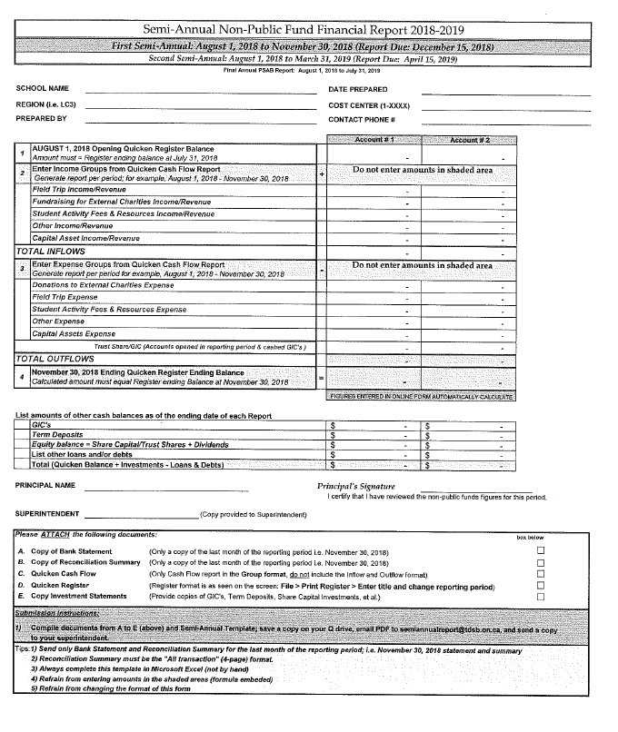

Other Topics

Gift in-Kind Donations
A gift in-kind is a donation other than cash. It does not include a gift of services. Examples which would qualify are computer equipment, books, furniture, etc. The date of donation is the date that the donor transfers legal ownership to the Board. The Board may issue a charitable donation receipt stating the fair market value of the donation once the object has been appraised. For new items, the amount of the donation receipt will be based on the original purchase receipt or appraised fair market value of the item. The donor is responsible for the cost of appraisal and delivery of the gifts in kind. School Councils must speak to the Principal prior to accepting the items. Donation receipt requests should be sent to the Trust and Donations Administrator in the General accounting department.
Tax Receipts
Donations generate invaluable resources for students. The TDSB issues charitable receipts or letters of acknowledgement for cash or cheque donations of $25 or over. Submission of the completed “Request to Issue Tax Receipt Form” along with the monetary donation are required for the issuance of an official tax receipt from the Board office. This form must be received at the Board office prior to December 15th to allow processing time of the tax receipt for the calendar tax year. Before indicating to a prospective donor that a tax receipt will be issued, the Principal must contact the Board office to assess whether the activity qualifies for a charitable donation receipt.
To request tax receipts for the donors, a Request for Tax Receipts AC-219 form must be completed by your school Office Administrator outlining the donor name, address and amounts, and intended purposes of the donations. The Request for Tax Receipts AC-219 form and the cheques are to be sent to the Trust & Donations Administrator of TDSB’s General Accounting department at 5050 Yonge Street, Toronto M2N 5N8, for deposit of the funds, and recording of the transaction.
Note that for donations are made through the Online Donation Module, tax receipts will be automatically issued by email. Tax receipts are issued online for donations of any amount.

Split Tax Receipt Rules – Can Donors receive a tax receipt if they are receiving goods in return?
The Canada revenue Agency (CRA) has clear rules around the split tax receipting process for registered charities.
CRA link: https://www.canada.ca/en/revenue-agency/services/charities-giving/charities/operating-a-registered-charity/issuing-receipts/split-receipting.html.
If the donor is receiving an advantage or goods in exchange for the donation, they must meet the following criteria in order to receive a tax receipt:
- If the fair market value of the advantage or goods received is valued at less than 10% of the donation (purchase amount), then the donor/purchaser can receive a donation tax receipt for 100% of the payment amount.
- If the fair market value of the advantage or goods received is valued at between 10%- 80% of the donation (purchase amount), then the registered charity can issue a tax receipt for the total donation amount minus the fair value of the advantage or goods received.
- If the fair market value of the advantage or goods received is valued at over 80% of the donation (purchase amount), then the registered charity cannot issue a tax receipt to the purchaser/donor.
Lotteries and Games of Chance
Lotteries and games of chance are governed by the Criminal Code of Canada which permits licensing of these activities. They may include bingo events, raffles, 50/50 draw, break open tickets and social gaming events. Board policy may prohibit School Councils from engaging in lotteries and games of chance, check with the Principal.

Rules and Regulations of the Alcohol and Gaming Commission of Ontario

Municipalities issue licenses for the smaller lotteries and games of chance in which School Councils may be involved. Specifically:
- Municipalities issue licenses for Bingo events with prize boards of up to $5,500
- Break open tickets for local organizations (Nevada tickets)
- Raffle lotteries for total prizes of $50,000 and under
- Bazaar lotteries which include wheels of fortune with a maximum bet of $2, raffles not exceeding $500, and bingo events up to $500.
If the School Council is involved in events that exceed these limits, they are required to obtain a license from the Alcohol and Gaming Commission of Ontario. https://www.agco.ca/lottery-and-gaming/charitable-lottery-licensing-overview

Entering into Contracts and Engaging Vendors

Corporate Sponsorships
Boards may enter into corporate sponsorships in order to enhance the educational opportunities and learning environment for students. Corporate sponsors exchange goods, money or services in return for advertising or other benefits. Please contact TDSB’s Business Development department at businessdevelopment@tdsb.on.ca or refer to P021 Fundraising Policy and PR508 Fundraising Procedures for more information.
Long-Term Agreements or Contracts
TDSB does not grant Principals or School Councils the authority to enter into long term agreements, since the commitment for future expenditure might exceed their term at the school. When a contract for goods or services spans across an extended period of time, or has significant financial implications, the school must consult with the Business Services department to obtain approval before proceeding.
Engaging Vendors
The agreement to engage a vendor, or to purchase a good or service, constitutes a contract. There are a number of different pathways for vendors to do business with TDSB.

Purchasing Department
The Board has a list of approved vendors that have been vetted by the Board. Schools should review the Purchasing department and Distribution Centre catalogues and purchase through approved vendors. If the goods or services you want are not available on the catalogues, please contact the TDSB Purchasing staff at purchasing@tdsb.on.ca.
Educational Programming Partnerships
Web link: https://pims.tdsb.on.ca/
For vendors who are interested in delivering programs during instructional hours on TDSB school sites.

Vendors will need to obtain approval from our Educational Partnership Office or by emailing partners@tdsb.on.ca.

The PIMS website provides a list of all partners and agencies that are approved to carry out educational programming at the TDSB.
Excursions and Event Facilities Directory
Web link: https://www.tdsb.on.ca/excursionsandevents/Login?returnurl=/excursionsandevents

For vendors who are interested in providing programs or events away from TDSB sites.

Vendors will need to obtain approval from our Risk management department and consult with our Legal department to review waivers and contracts. Please email schoolactivities@tdsb.on.ca for more details.

Approved Fundraising Vendors, Distribution of Materials, Grants/Scholarships
Web Link: https://oursite.tdsb.on.ca/org/DOM/default.aspx

For companies that are interested in becoming an approved fundraising vendor or sponsor, or who are interested in distributing flyers or other materials to our schools. Please email businessdevelopment@tdsb.on.ca for details.
TDSB Permit Application
Web Link: https://tdsb.ebasefm.com/rentals/welcome

For vendors who are interested in providing programs or events, on TDSB sites, outside of instructional hours, a permit is required. Please contact permits@tdsb.on.ca for details.

When School Councils are engaging fee-for-service contractors or vendors to deliver after-school programs, they must direct them to TDSB Permit Department to obtain a permit. Please attach the permit with the purchase order or requisition when initiating payment through the Board.

School Council Insurance

Many School Councils are very active in their community, and on occasion, participate or organize events that are not under the control of the TDSB. In these situations, the Board’s liability policy may not provide protection to the School Council, its members or volunteers acting on behalf of the School Council. As such, it is important to ensure that your School Council has appropriate insurance coverage in place to protect the members and volunteers.
Insurance is available for council executives and volunteers acting on behalf of the School Council. Coverage begins on November 1st and extends for a year. This insurance is to cover various liabilities arising out of injuries to third parties or damage to leased or borrowed premises. School Council members are fully protected by TDSB’s liability insurance while performing advisory duties.
Please contact risk.management@tdsb.on.ca for details.

Appendix A: TDSB School Cash Online Donations Module Quick Guide and Frequently Asked Questions

The TDSB Online Donations Module allows all TDSB schools to collect and track online donations. Donations received are automatically deposited into the TDSB bank account and tracked in the school budgets. All donations, of any amount, will qualify for a tax receipt which the Donors will receive automatically through email. Donors can also retrieve and reprint tax receipts by logging onto the School Cash Online website.
All TDSB schools have access to this Online Donations Module.
INSTRUCTIONS:
- Donors should be directed to https://tdsb.schoolcashonline.com/ to make online donations.

- Click on “ITEMS” on the right of the top bar.

- Click on the “Make A Donation” button on the page.

- You will be brought to the online donation page. The site can also be accessed via this link: https://tdsb.schoolcashonline.com/Fee/Details/457/153/false/true

- The donor is required to enter the donation amount under “Gift Information” and choose the school they wish to donate to by clicking the “Fund Destination” drop down menu.
*Please note that these donations are intended for TDSB internal fundraising purposes only and are not intended for redistribution to other external charitable organizations.*

- If the funds are designated for a specific purpose, please indicate the purpose under the Message field in the “Message to School Board” section.

- Click “Add To Cart” at the bottom of the screen.

- Review the items outlined in your cart. You may make donations to multiple schools in one transaction by clicking “Select More Items”. Once you are ready to proceed to the checkout, click “Continue” at the bottom of the cart screen.

- /All Donors will be required to log in or register for an account before proceeding to the payment page. This will allow Donors to retrieve and reprint donation receipts in the future. If you are a new user, please click the hyperlink beneath the Sign In button, “Click here to register now” and follow the registration prompts.

- Once donors have completed the registration and checkout process, they will receive a copy of the donation receipt via email. The donation will be made in the name of the account holder.

- The donations will be processed centrally through the TDSB General Accounting Department. Donation reports are available from the Business Services Help Desk (businesshelpdesk@tdsb.on.ca) or from your Finance Support Officer. The Donation Report will capture donations received up to 24 hours before the report was generated. It can take up to two weeks for the donations to appear in the school’s budget. This is when School Administrators would be able to see the online donations received, under the Donation Cost Centre xxxx0135.

- Separate customized web links are available for each school. By advertising the customized links, donors would not be required to choose the fund destination from the drop down menu.
Please click here to find the link for your school.

The links are usually in the following format: “https://tdsb.schoolcashonline.com/Fee/Details/457/153/false/true?fundDestination=Name of your school”.

For example: For AY Jackson Secondary School, the link is: https://tdsb.schoolcashonline.com/Fee/Details/457/153/false/true?fundDestination=A Y Jackson Secondary School

- The donation reports generated from School Cash Online are available in Excel/.CSV or PDF formats. Schools should redact any private information on the report (such as donor address or tribute information, or donors who wish to remain anonymous) before distributing it to individuals outside of the school.

Sample report – Donation Report (exported to Excel)

Frequently Asked Questions
Q: Can School Councils collect funds through the Online Donation Module?
A customized donation web link can be created for each School Council or new school fundraising initiative. This way, School Councils can advertise the donation web link through their website and donors can donate directly to that initiative upon entering the site. Donors will not need to choose a fund destination from a drop down menu. To request a customized weblink, please email us at businesshelpdesk@tdsb.on.ca.

The donations collected through the platform are directly deposited into the school’s budget, under the school budget’s Donation cost center (CC#XXXX0135). These transactions are posted into the SAP system on a bi-monthly basis.

Real time reports of donations received are accessible by TDSB Finance department staff. If the school or School Council would like reports of their donations received to be sent to them more frequently, they may email businesshelpdesk@tdsb.on.ca to request those reports. The Principal’s authorization is required for Finance staff to send donation reports to TDSB School Council email accounts.

Q: Can School Councils request for donations collected to be redirected to another bank account, (e.g. non-board, School Council or nutrition bank account)?

Donations to TDSB cannot be transferred or redirected to other entities or bank accounts, unless considered necessary under special circumstances. Also, all Board purchases should be made through the Board’s financial systems to take advantage of Board contracts and HST rebates. The Board tracks expenditures purchased from donation proceeds, as these transactions are captured on the TDSB’s annual charity return submitted to the Canada Revenue Agency.

Q: Can the Online Donation Module be used when a parent wants to pay for their child’s school activity fees, field trips or nutrition program contributions?
The Online Donation Module is used for collection of monetary donations, where the donors do not directly receive any products or services in return for their donation. Donors will receive an income tax receipt for their donation. To pay for students’ activity fees, field trips or nutrition program fees, they must log in to their School Cash Online account, and pay through the fee payment portal. The Online Donation Module is not to be used to pay for student fees.
Q: Can a donor get a refund if they made a donation in error through the Online Donation Module?
Donations made through the Online Donation Module are non-refundable. Please review the transaction carefully before checking out.
Q: Can a donor request a revised tax receipt if the information on the receipt is incorrect?
The donation tax receipt will be issued in the name of the School Cash Online account holder. If the donor wants to issue the tax receipt under a different name, they will need to request the tax receipt through our Trust & Donations department, instead of through the Online Donation Module. Note that under Canada Revenue Agency guidelines, the tax receipt must be issued to the entity or individual who provided the donation. Please contact us at businesshelpdesk@tdsb.on.ca for more information.
Q: Does the Board charge any usage fees for donations through the Online Donation Module?
The Online Donation Module is incorporated in the annual fee of the School Cash Online system, and is paid for centrally. The Board does not charge schools or School Councils any usage fees associated with the use of the Online Donation Module. However, the actual cost of the merchant services (credit card) transaction fees are charged against the donations received by each school or School Council on a semi-annual basis. There are no transaction fees deducted for donations made by e-cheque or interac. The total donation amount will be shown on the donation tax receipt regardless of the payment method chosen.

Need Assistance?
If you have any questions regarding School Council business processes, please contact your school’s Finance Support Officer, or contact our Business Help Desk at 416-395-8080 or businesshelpdesk@tdsb.on.ca.
Finance Support Officers
Paula.McLaughlin@tdsb.on.ca | 416-395-8042
Abby.Olubode@tdsb.on.ca | 416-394-7258
Helen.Harela@tdsb.on.ca | 416-395-9638
Brandie.Waldriff@tdsb.on.ca | 416-393-0146
Susanne.Foster@tdsb.on.ca | 416-395-8044
Ellen.Kastner@tdsb.on.ca | 416-395-9639
Janis.Walker@tdsb.on.ca | 416-393-0472
Tina.Gillis@tdsb.on.ca | 416-395-9640



