
Name of Committee: Alternative Schools Community Advisory Committee
Meeting Date: 13 December 2021
A meeting of the Alternative Schools Community Advisory Committee convened on December 13, 2021 from 6:30pm to 8:45pm pm via Virtual Meeting (Zoom) with Angela Matich and Laurie McAllister (Co-Chairs) presiding.
Membership  Attendance: | Gaia Friedman (Student, Spectrum Alternative Senior School, ASCAC Elementary School Student Member), Joanne Huber (Parent, High Park Alternative JS, ASCAC Member), Olga Ingram (Parent, Alternative Scarborough Education 1, ASCAC Member), Yo’av Kaplan (Parent, Avondale Secondary Alternative School, ASCAC Member), Shelley Laskin (Trustee Ward 8, ASCAC Trustee Member); Angela Matich (Parent, Equinox, ASCAC Co-Chair); Laurie McAllister (Parent, Avondale Secondary Alternative School, ASCAC Co-Chair), Ben Singer (Parent, Mountview Alternative JS, ASCAC Member), Sara Wilken (Parent, Beaches Alternative, ASCAC Member)
Staff Lead: | Peter Chang (System Superintendent, Interim)
Recorder: | Anna Catalano, ASCAC Committee Assistant
Guests: | Also present were: See Appendix A for the Registration List
Regrets: | NIL

ITEM | DISCUSSION | ACTION ITEM
- Welcome/ Introductions | Laurie McAlister, Secondary Alternative School Parent Co-Chair welcomed everyone and introduced the Committee Members and welcomed Trustees MacLean and Smith.
- Land Acknowledgement | Gaia Freidman, Elementary Alternative School Student Member read the Land Acknowledgement.
- Approval of Agenda | The agenda was approved.
- Declarations of Possible Conflicts | No conflicts were declared.
- ASCAC Community Building Sub-Committee  - Elementary Alternative School Councils “Share & Learn” Zoom Workshop  - Middle School Fun Day | Elementary Alternative School Councils “Share & Learn” Zoom Workshop  ASCAC Elementary School Co-Chair Angela provided an overview of this workshop. The workshop will be held in February 2022 and an email will be sent in the new year with the details of the workshop. The goal of the workshop is to have one to two school council representatives from each of the 19 elementary alternative schools to attend the workshop and to share information about how their schools are doing, what challenges they face, etc. This is a way to start community building within the 19 elementary alternative schools.  Middle School Fun Day  Megan, an ASCAC Community Building Sub-Committee member, provided an overview of this event. The Middle School Fun Day is meant to bring together alternative middle schools (students in grades 7 and 8) to build a community within these schools. The event will be organized by volunteers in a park and will be a free event. There will stations with different games and activities – this is a way to encourage team building between schools and different schools. Snacks will also be available. The Middle School Fun Day will be a pilot project with only two to three schools being invited to the event in Spring 2022. The hope is to build and expand the event, though this will depend on the success of the spring 2022 event. Further details about this event will be shared at ASCAC meetings as they become available.  ASCAC Co-Chair Trustee Laskin supports the both events though was wondering, moving forward, if the event could happen in the fall. The rationale for this would be that there could be discussions about secondary alternative schools with the alternative middle schools. Middle school students are thinking about applying to high school and this would be a great way to promote and increase knowledge of secondary alternative schools.  ASCAC Elementary School Co-Chair Angela mentioned that the sub-committee members talked about the possibility of hosting the events in the fall/ start of the school year. They chose to host a smaller event in spring 2022 to ensure that the events could be managed and to see if the events are successful. Plans are to have larger events at the beginning of the school years.
- ASCAC Equity Sub-Committee  - Motion 1: TDSB Marketing  - TDSB Website - Find Your School  - Motion 3: Elementary Alternative Schools’ Enrolment Allocations | The following three ASCAC Equity Sub-Committee motions were presented to the ASCAC members to vote on as recommendations to the Board.  TDSB Equitable Marketing  The Alternative Schools Community Advisory Committee recommends that the TDSB conducts a review on how the Board can promote more, do more with the same or similar marketing pieces, campaigns, and budgets. Take every marketing opportunity and optimize it to its full potential. Why promote just one option, when TDSB can simultaneously promote more or all options for the same or similar cost and time (see Appendix B for additional information).  Joanne, an ASCAC, and ASCAC Equity Sub-Committee Member provided information on the TDSB Equitable Marketing motion. The motion was moved and passed, and the following recommendation will be included in the Standing Committee report which will be presented at the January 19, 2022 Program School and Services Committee (PSSC) meeting.  TDSB Website: Find Your School  The Alternative Schools Community Advisory Committee recommends that the TDSB conducts a review on how the TDSB can improve the existing Find Your School website section to improve knowledge of, and thereby, access to all existing TDSB schools, services, and programs including, but not limited to, alternative schools. The current design assumes web users already have a basic understanding that TDSB offers numerous options outside their local home school, what those options are, which options the student in question is eligible to attend, where they are located, and how to access them (see Appendix C for additional information).  Angela, ASCAC, and ASCAC Equity Sub-Committee Co-Chair provided information on the TDSB Website: Find Your School motion.  Co-Chair Trustee Laskin asked Peter Chang, ASCAC’s Staff Resource Person, if he remembered a conversation at PSSC regarding staff talking about the refining the Find Your School tool? Trustee Laskin also mentioned that this motion can support the work staff is undertaking with refining the Find Your School tool.  Trustee MacLean mentioned that he sits on PSSC and remembers the conversations Trustee Laskin mentioned. Trustee MacLean mentioned that the motion for equitable marketing will be easier to execute. The motion for Find Your School is very specific about what is being asked. PSSC will want the Communication team to also speak to this and to hear their thoughts about this recommendation. There may be some changes to this motion as Communication may want to explore what can be done. We need to ensure that the final recommendations include report back dates to PSSC.  Peter mentioned that this recommendation may be a joint effort between the Communication Team and IT Services. They will need time to see what can and cannot be accomplished. PSSC will need to provide specific directions to staff and ask them to report back with their findings. This recommendation may be top explore the possibility of whether the Find Your School tool can handle the requests in this motion.  The motion was moved and passed, and the following recommendation will be included in the Standing Committee report which will be presented at the January 19, 2022 Program School and Services Committee meeting.  Elementary Alternative Schools Enrolment Allocation  The Alternative Schools Community Advisory Committee (ASCAC) recommends that the TDSB conducts a review for TDSB staff to remove existing barriers and consider all operations and specifications, including building space capacity and wait lists, to maximize enrolment numbers for all elementary alternative schools so they may serve as many students as feasible. Furthermore, ASCAC requests the Board to provide a rationale for the allocated enrolment numbers for elementary alternative schools (see Appendix D for additional information).  Angela, ASCAC, and ASCAC Equity Sub-Committee Co-Chair provided information on the Elementary Alternative Schools Enrolment Allocation motion.  There were discussions around transparency of enrolment numbers and caps for this motion. Since transparency is vague…it was decided that the following wording be used: the Board is to provide a rationale for the allocated enrolment numbers for elementary alternative schools.  There was support of this motion going forward as a recommendation to the Board. ASCAC is a Committee of the Board and can request the information referenced in this motion as this is not an unreasonable request. TDSB Staff should be able to report back and inform the Committee when the choices were made, and the factors involved when making these choices.  It was also mentioned that TDSB Staff attended the April 2021 ASCAC meeting to give a presentation about the procedures for secondary alternative school staffing allocations. Click here to review the minutes on the 2021-2022 TDSB Alternative Schools Staff Allocation presentation. | The Committee Assistant will ensure that the three motions are on the Standing Committee report which will be presented at the January 19, 2022 Program School and Services Committee meeting
- Secondary Alternative Schools | ASCAC Secondary School Co-Chair Laurie provided a background of her experiences with secondary alternative schools.  Laurie mentioned that the population and needs for the elementary and secondary alternative schools are quite different. Laurie provided some examples and information about secondary alternative schools which can be found in the Review of Alternative Schools: Research Analysis 2016-17 Report.  Laurie discussed the differences between secondary alternative schools versus elementary alternative (and the TDSB overall), including that some secondary alternative schools support students who are more in risk than the TDSB overall.  ASCAC is forming a subcommittee to develop proposals related to the viability of Secondary Alternative Schools and their programming. The purpose of the subcommittee is to:  - build awareness of the need for secondary alternative schools in relation to the TDSB’s commitment to equity, mental health issues, and student re-engagement.  - develop recommendations to be presented to the Board on an urgent basis to stabilize secondary alternative schools, including as a pandemic-related priority.  There were discussions as to whether a Secondary Subcommittee is what is needed or could a Task Force be formed under the Equity Subcommittee.  It was mentioned that the Secondary Subcommittee doesn’t really fit under the Equity Subcommittee and these concerns are more about the viability of secondary alternative schools programming.  It was mentioned that staffing is generated on enrolment and this would work for the regular TDSB schools though a different approach may be needed when staffing secondary alternative schools, which would be based on program viability. Secondary alternative schools need to be staffed appropriately for programs to be offered as you can’t increase enrolment without programs and if there isn’t staff then the program(s) can’t be offered. Secondary alternative schools have a purpose which is much different then regular secondary schools. During this pandemic, the students who are in risk need the secondary alternative schools – they need the programs and support. | Laurie to send to the Committee Assistant information/ invitation regarding the new subcommittee. The Committee Assistant will ensure that an email is sent to the ASCAC email list
- TDSB Elementary Alternative Schools Application Form & Procedures Update | Peter Chang (System Superintendent and ASCAC Staff Lead) and Alex Tracey (Principal) provided an update of the TDSB Elementary Alternative Schools Application Form & Procedures.  They explained that the purpose of the new procedure is to provide clear and consistent details for how and when to apply for Elementary Alternative Schools within the Toronto District School Board. The new Application Form refers to a centralized online form for students and their families to complete if they wish to attend and Elementary Alternative School of their choice.  To date the following actions are completed:  - Formed the Elementary Alternative Schools Application and Admission Procedures Working Group which includes: System Superintendent, Superintendents of Education, and Principal  - Met with the Administrators and Superintendents of Elementary Alternative Schools to inform them of the Board Motion and the requirements for the application/admission form  - Consulted with various TDSB offices/ departments  In the new year, a Feedback Session will be organized for all CAC Chairs and Co-Chairs who wish to attend. The purpose of this meeting is to gather feedback on the application form and new procedures.
- TDSB Board-Wide Updates | Trustee Laskin and System Superintendent Peter Chang deferred their updates as the meeting was running late and they wanted to ensure meeting attendees had time to speak during Open Floor.
- Open Floor | Any meeting attendee could bring forth any matter they wished to discuss with ASCAC. Participants were welcomed to ask questions, provide feedback and or let the Committee know of any concerns they may have. Students, alumni, parents, and staff spoke about their concerns about the staffing cuts at the secondary alternative schools and were supportive of the new Secondary Sub-Committee that was being formed.
- Closing Remarks & Adjournment | Meeting was adjourned at 8:39pm
- Next Meeting | February 7, 2022 from 6:00 pm – 8:00 pm

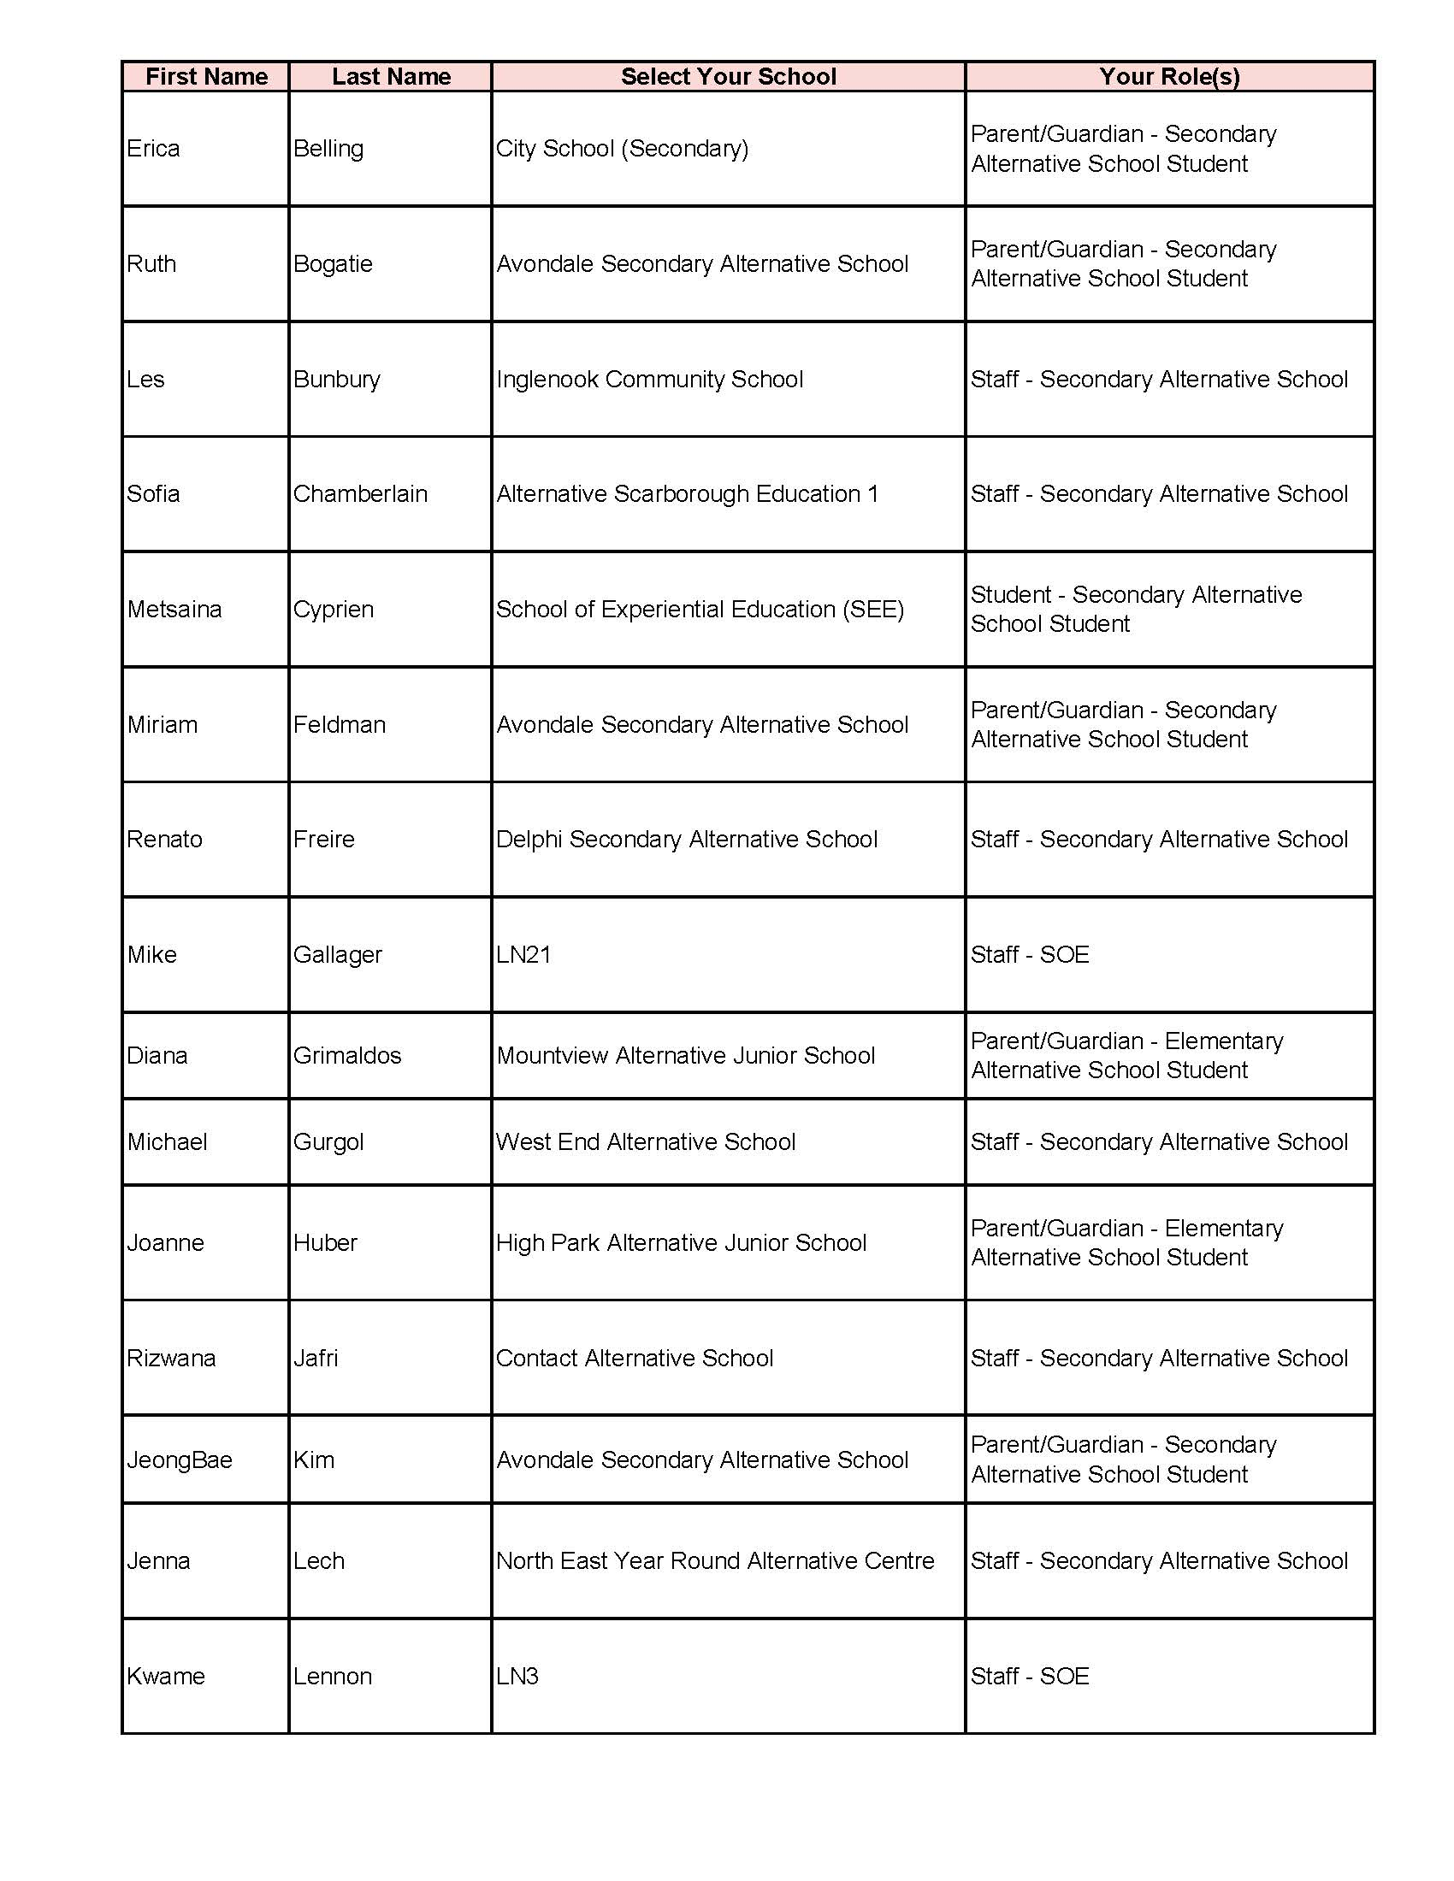
APPENDIX A
ASCAC December 13, 2021 Meeting Attendees

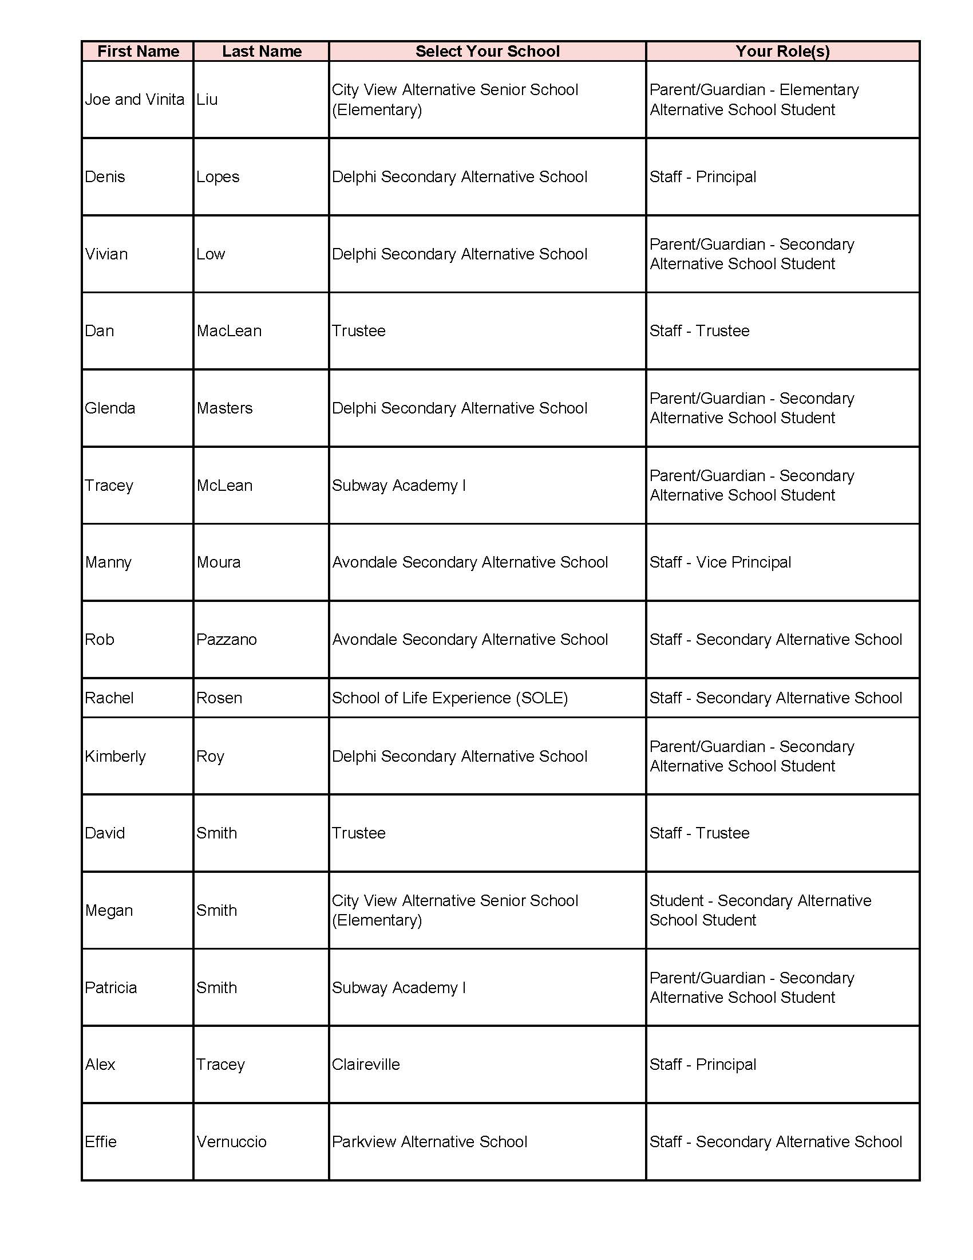

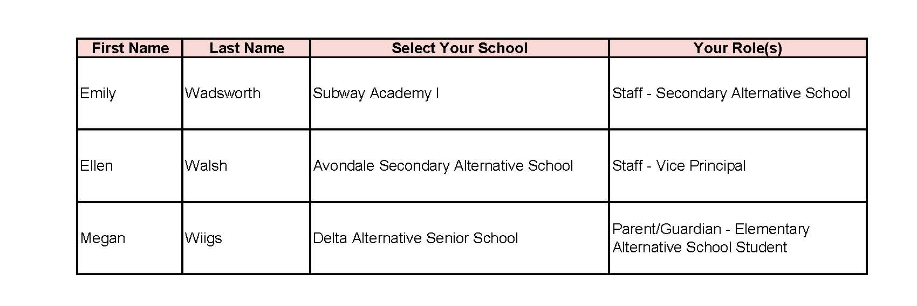

APPENDIX B
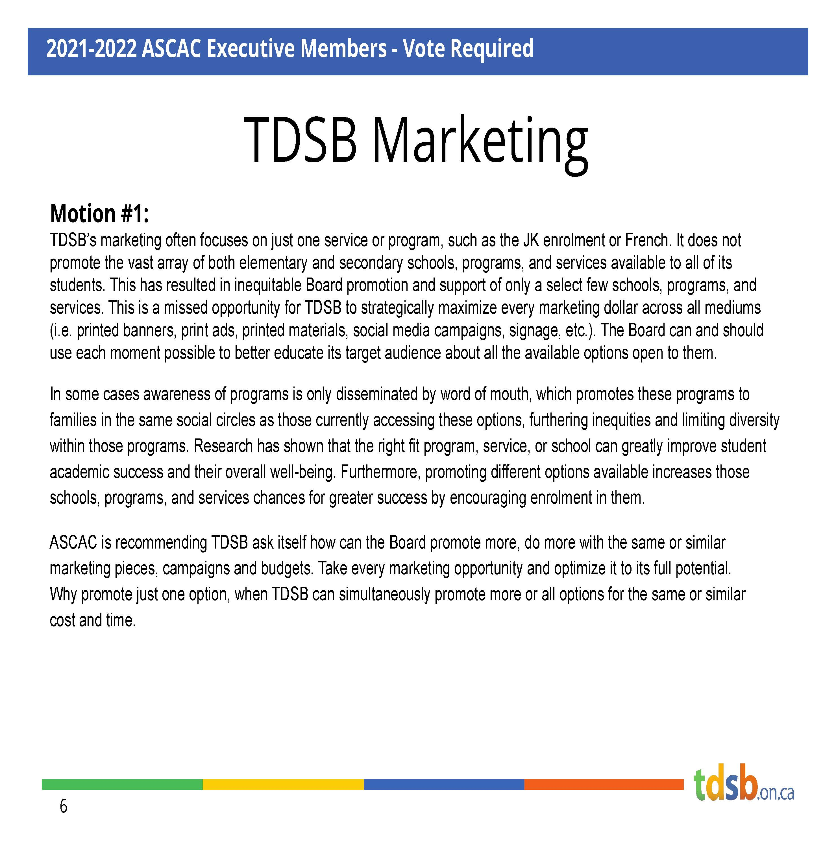

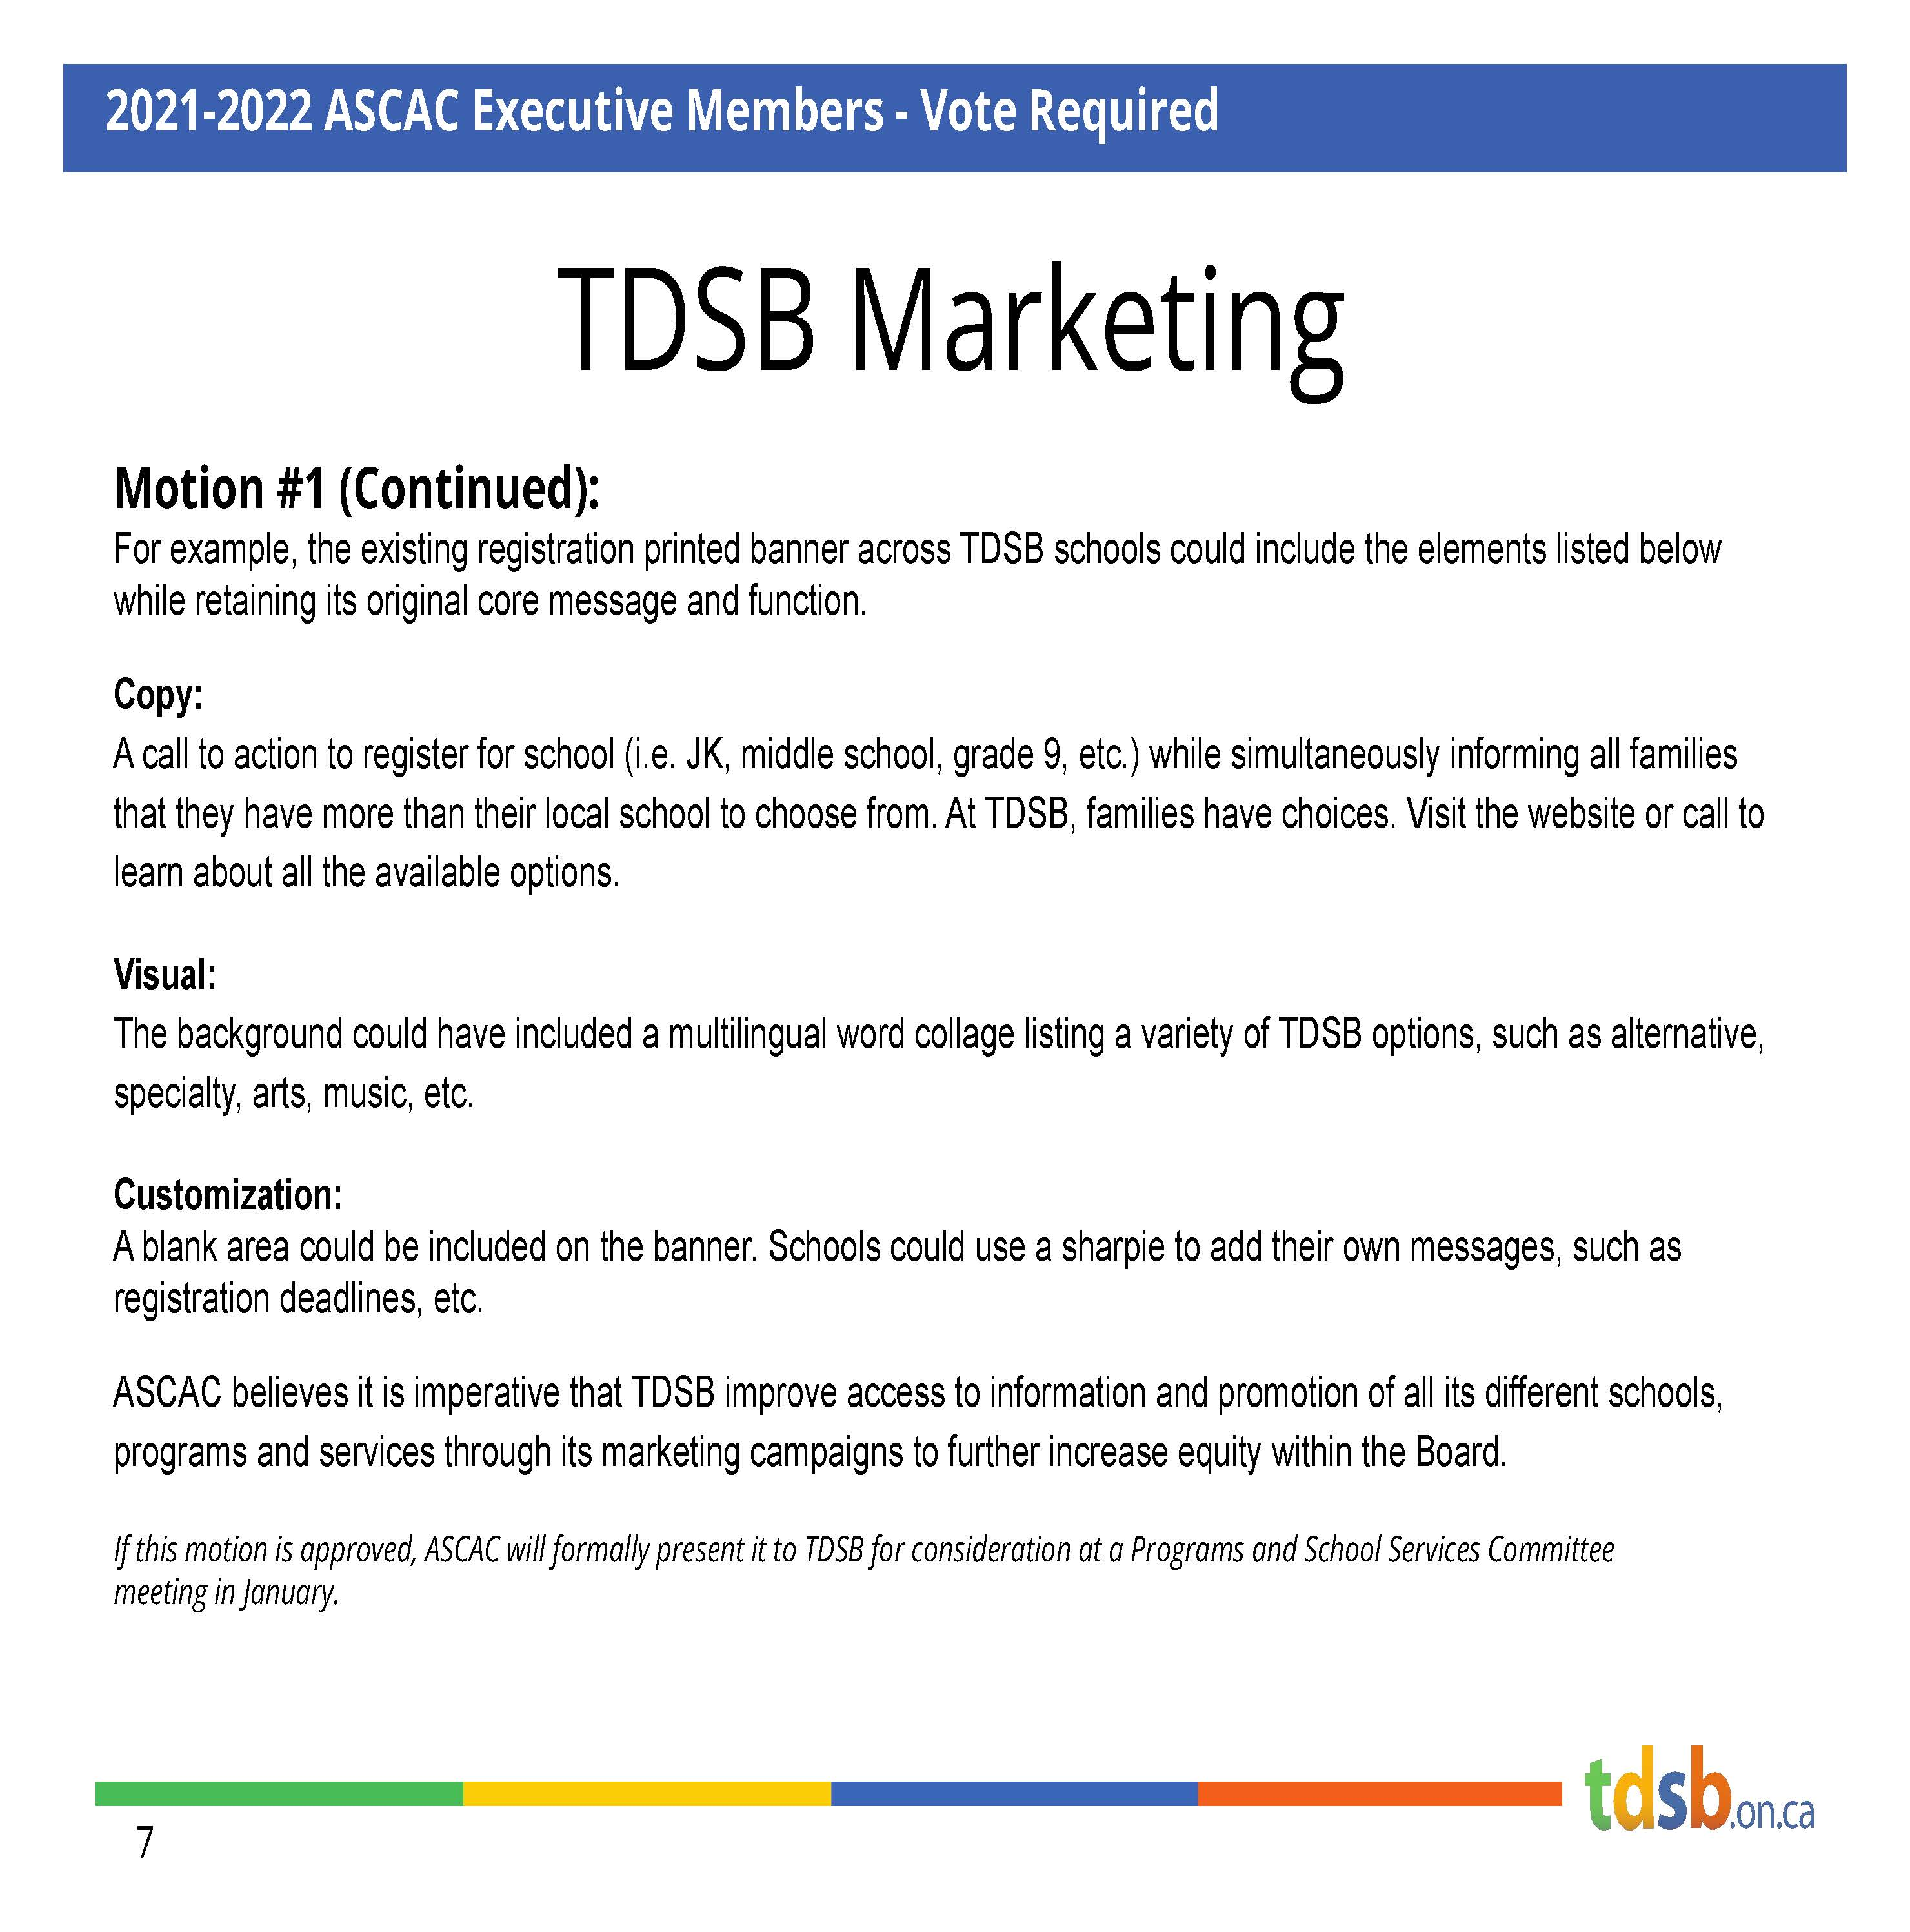

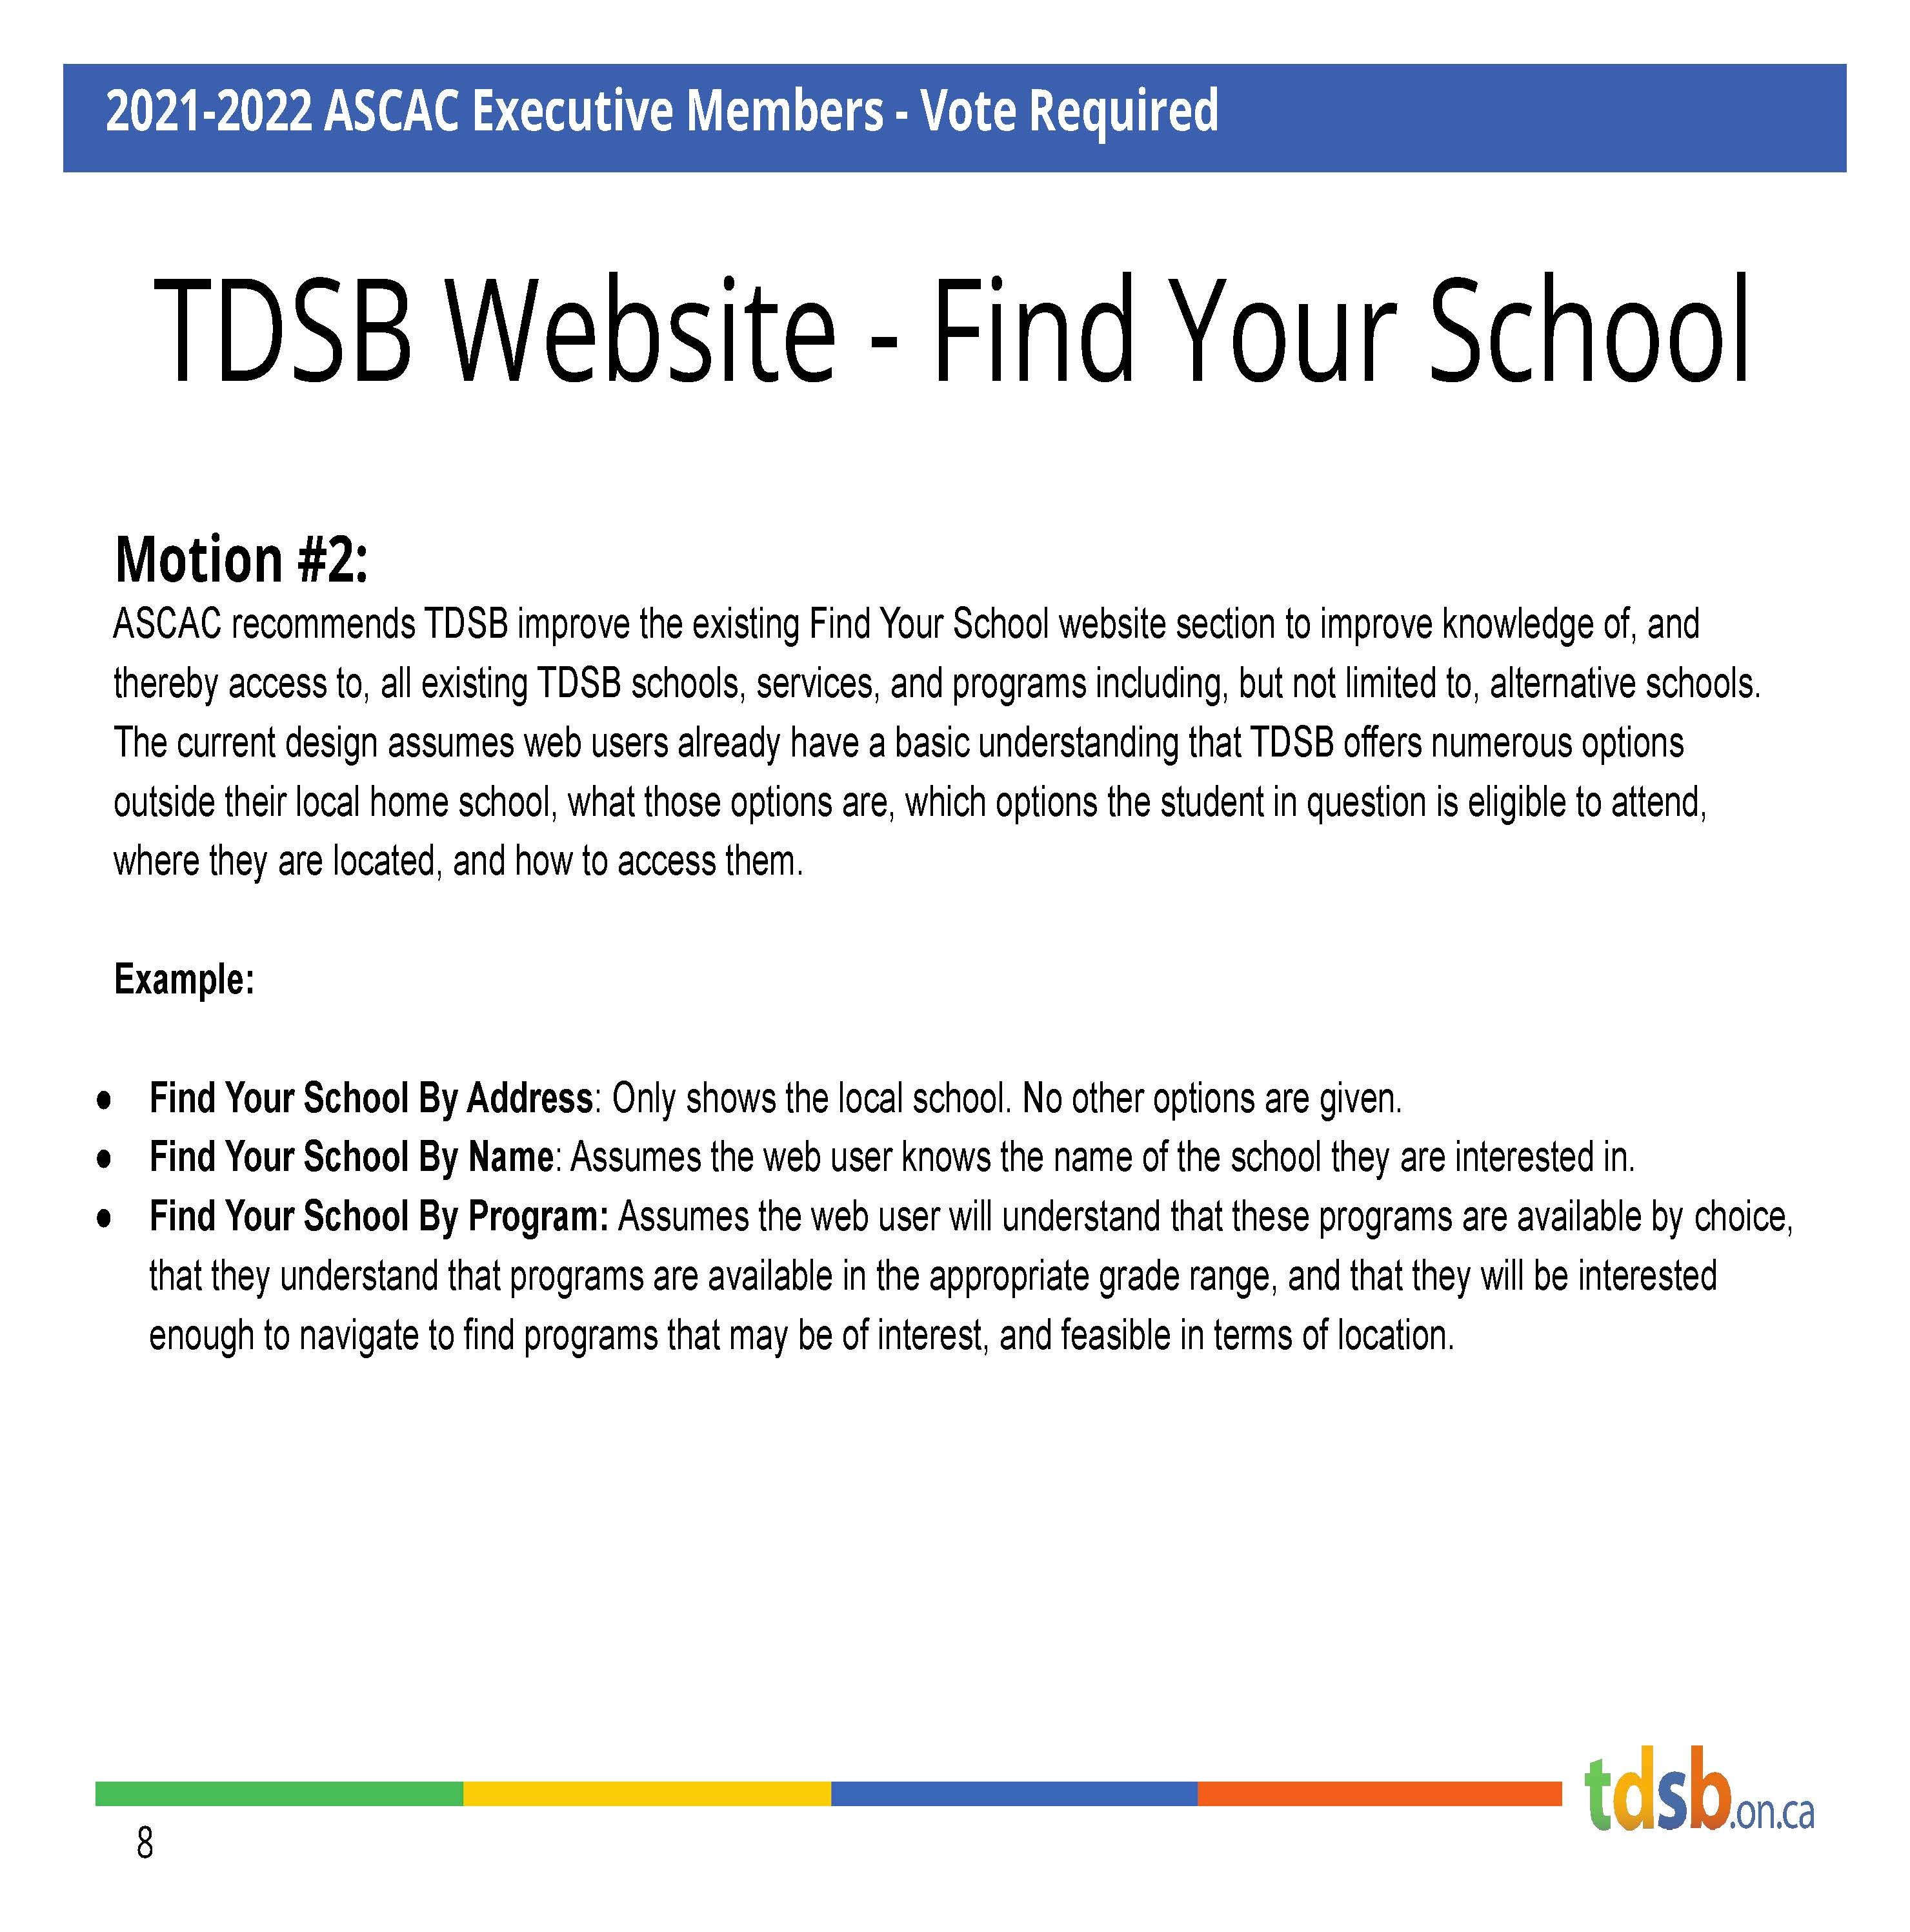
APPENDIX C
APPENDIX D

